Top 1 [Recreational Services](http://www.kent.edu/recservices)

ADDRESS:

1550 Ted Boyd Drive, Kent, Ohio 44242

PHONE:

330-672-4732

website: <http://www.kent.edu/recservices>

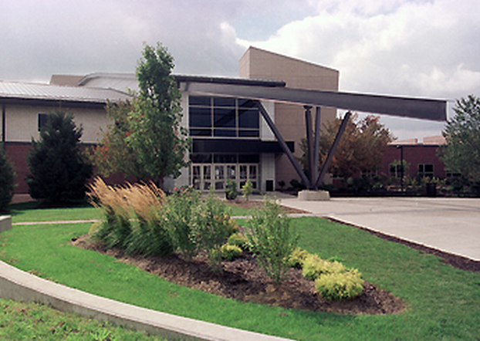

Top 2 Ice Arena

330-672-7465

address: 650 Loop Road, Kent, Ohio 44240

website: <http://www.kent.edu/recservices/ice-arena>

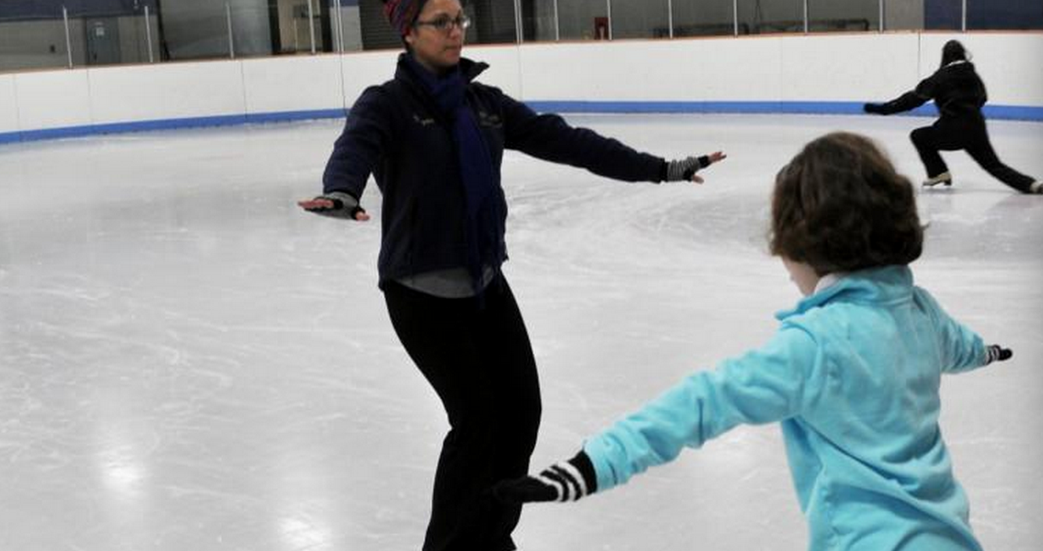

Top3 baseball

见campus 一样的

Top 4 basketball

Website：<http://www.kentstatemensbasketballcamps.com>

Addressed： MAC Center Kent State University,kent, Ohio 44240

**330-672-2495**

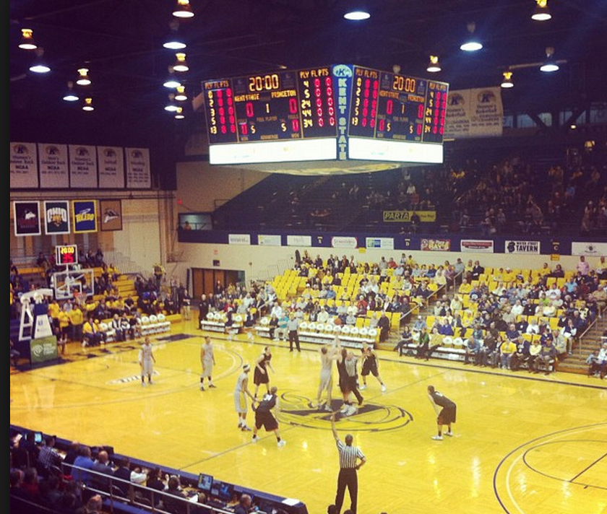

Top5 (Golf) Sunny Hill

Website: http://www.sunnyhillgolfcourse.com/

Phone: 330-673-1785  
            or 330-676-GOLF

Address: 3734 Sunny Brook Road  
              Kent, Oh 44240

